Statistical Analysis of Housing Prices and Square Footage in King County, Washington

STA 108 Applied Statistical Methods: Regression Analysis

Professor: Erin Melcon

October 27th, 2017

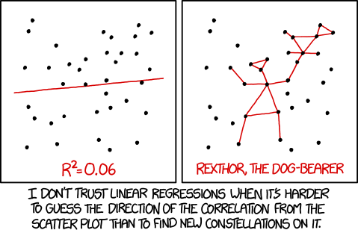

*“ With a 95% confidence interval suggests that Rexthor’s dog could also be a cat, or possibly a teapot”*

*Source:* [*www.xkcd.com/1725*](http://www.xkcd.com/1725)

Duke LeTran

995965920